Enriched American History
Round Robin Group Resources
Mr. Koch

The Roaring Twenties: Station One
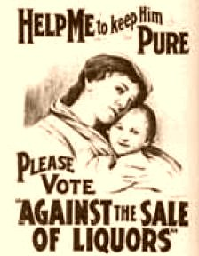

The Roaring Twenties: Station One

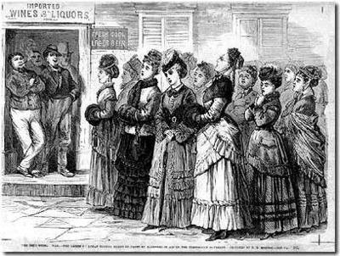
The "Ladies of Logan" sing hymns in front of bars in aid of the temperance movement

The Roaring Twenties: Station One

Historical Importance of Prohibition:
Prohibition was a period of nearly fourteen years of U.S. history in which the manufacture, sale, and transportation of liquor was made illegal. It led to the first and only time an Amendment to the U.S. Constitution was repealed.

Dates:
1920 -- 1933

Also Known As:
Noble Experiment

Overview of Prohibition:
Prohibition was the period in United States history in which the manufacture, sale, and transportation of intoxicating liquors was outlawed. It was a time characterized by speakeasies, glamor, and gangsters and a
period of time in which even the average citizen broke the law.

Temperance Movements:
The push for Prohibition began in earnest in the nineteenth century. After the American Revolution, drinking was on the rise. To combat this, a number of societies were organized as part of a new Temperance movement which attempted to dissuade people from becoming intoxicated. At first, these organizations pushed moderation, but after several decades, the movement's focus changed to complete prohibition of alcohol consumption.

The Temperance movement blamed alcohol for many of society's ills, especially crime and murder. Saloons, a social haven for men who lived in the still untamed West, were viewed by many, especially women, as a place of debauchery and evil. Prohibition, members of the Temperance movement urged, would stop husbands from spending all the family income on alcohol and prevent accidents in the workplace caused by workers who drank during lunch.

The 18th Amendment Passes
In the beginning of the 20th century, there were Temperance organizations in nearly every state. By 1916, over half of the U.S. states already had statutes that prohibited alcohol. In 1919, the 18th Amendment to the U.S. Constitution, which prohibited the sale and manufacture of alcohol, was ratified. It went into effect on January 16, 1920.

The Volstead Act
While it was the 18th Amendment that established Prohibition, it was the Volstead Act (passed on October 28, 1919) that clarified the law. The Volstead Act stated that "beer, wine, or other intoxicating malt or vinous liquors" meant any beverage that was more than 0.5% alcohol by volume. The Act also stated that owning any item designed to manufacture alcohol was illegal and it set specific fines and jail sentences for violating Prohibition.

Loopholes
There were, however, several loopholes for people to legally drink during Prohibition. For instance, the 18th Amendment did not mention the actual drinking of liquor. Since Prohibition went into effect a full year after the 18th Amendment's ratification, many people bought cases of the-legal alcohol and stored them for personal use. The Volstead Act allowed alcohol consumption if it was prescribed by a doctor. Needless to say, large numbers of new prescriptions were written for alcohol.

Gangsters and Speakeasies
For people who didn't buy cases of alcohol in advance or know a "good" doctor, there were illegal ways to drink during Prohibition. A new breed of gangster arose during this period. These people took notice of the amazingly high level of demand for alcohol within society and the extremely limited avenues of supply to the average citizen. Within this imbalance of supply and demand, gangsters saw profit. Al Capone in Chicago is one of the most famous gangsters of this time period.

These gangsters would hire men to smuggle in rum from the Caribbean (rum runners) or hijack whiskey from Canada and bring it into the U.S. Others would buy large quantities of liquor made in homemade stills. The gangsters would then open up secret bars (speakeasies) for people to come in, drink, and socialize.

During this period, newly hired Prohibition agents were responsible for raiding speakeasies, finding stills, and arresting gangsters, but many of these agents were under-qualified and underpaid leading to a high rate of bribery.

Attempts to Repeal the 18th Amendment
Almost immediately after the ratification of the 18th Amendment, organizations formed to repeal it. As the perfect world promised by the Temperance movement failed to materialize, more people joined the fight to bring back liquor. The anti-Prohibition movement gained strength as the 1920s progressed, often stating that the question of alcohol consumption was a local issue and not something that should be in the Constitution.

Additionally, the Stock Market Crash in 1929 and the beginning of the Great Depression started changing people's opinion. People needed jobs. The government needed money. Making alcohol legal again would open up many new jobs for citizens and additional sales taxes for the government.

The 21st Amendment Is Ratified
On December 5, 1933, the 21st Amendment to the U.S. Constitution was ratified. The 21st Amendment repealed the 18th Amendment, making alcohol once again legal. This was the first and only time in U.S. history that an Amendment has been repealed.

The Roaring Twenties: Station Two

Nineteenth Amendment
Passed by Congress June 4, 1919.
Ratified August 18, 1920.
Section 1: The right of citizens of the United States to vote shall not be denied or abridged by the United States or by any State on account of sex.
Section 2: Congress shall have power to enforce this article by appropriate legislation.

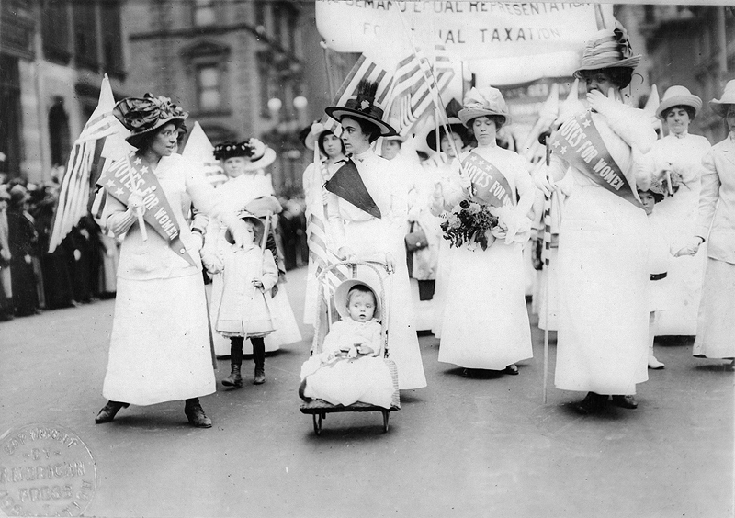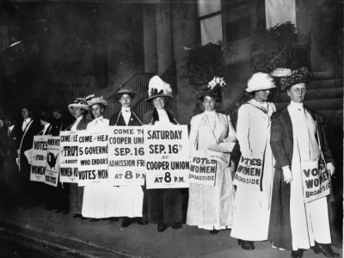

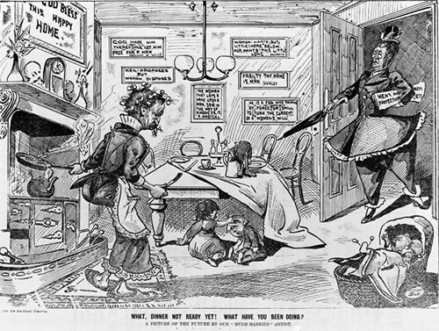

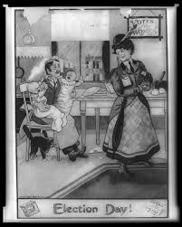

The Roaring Twenties: Station Three
Harlem Renaissance

Background
Spanning the 1920s to the mid-1930s, the Harlem Renaissance was a literary, artistic, and intellectual movement that kindled a new black cultural identity. Its essence was summed up by critic and teacher Alain Locke in 1926 when he declared that through art, "Negro life is seizing its first chances for group expression and self determination." Harlem became the center of a "spiritual coming of age" in which Locke's "New Negro" transformed "social disillusionment to race pride." Chiefly literary, the Renaissance included the visual arts but excluded jazz, despite its parallel emergence as a black art form.

Harlem Renaissance
The nucleus of the movement included Jean Toomer, Langston Hughes, Rudolf Fisher, Wallace Thurman, Jessie Redmon Fauset, Nella Larsen, Arna Bontemps, Countee Cullen, and Zora Neale Hurston. An older generation of writers and intellectuals--James Weldon Johnson, Claude McKay, Alain Locke, and Charles S. Johnson--served as mentors.
The publishing industry, fueled by whites' fascination with the exotic world of Harlem, sought out and published black writers. With much of the literature focusing on a realistic portrayal of black life, conservative black critics feared that the depiction of ghetto realism would impede the cause of racial equality. The intent of the movement, however, was not political but aesthetic. Any benefit a burgeoning black contribution to literature might have in defraying racial prejudice was secondary to, as Langston Hughes put it, the "expression of our individual dark-skinned selves."
The Harlem Renaissance influenced future generations of black writers, but it was largely ignored by the literary establishment after it waned in the 1930s. With the advent of the civil rights movement, it again acquired wider recognition.
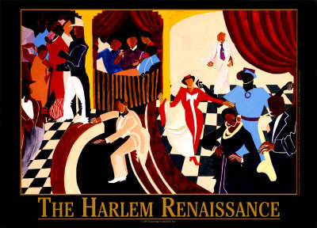

The Roaring Twenties: Station Four

Charles Lindbergh
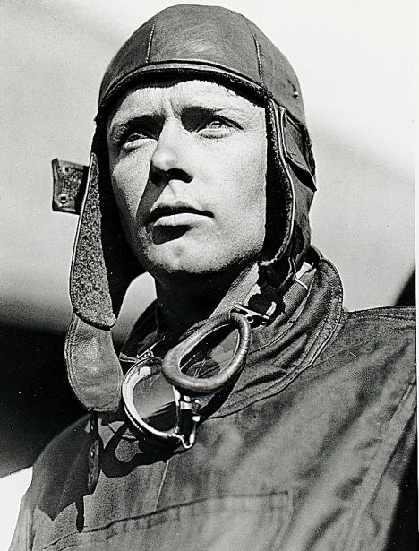
1902-1974

“A tall, slender young aviator pilot named Charles A. Lindbergh bailed out four times without ever losing faith in aviation. In 1927 Lindbergh took off from Roosevelt Field, Long Island, in a tiny plane, and headed out over the
ocean, bound for Europe. Some 33½ hours later he landed in Paris—and was stunned by the hysterical acclaim that greeted him. It was a justified tribute, for Lindbergh‟s exploit, the first nonstop solo transatlantic flight, was the transcendentally dramatic event, which proved that the age of air transportation had truly begun. With this flight, the world was suddenly smaller.”

Babe Ruth
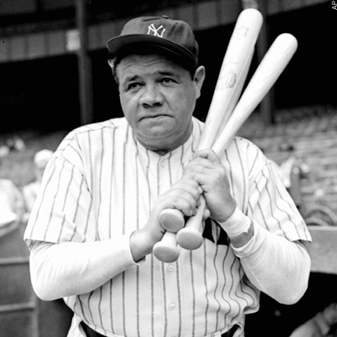
1895-1948

“W.O. McGeehan wrote, „Babe Ruth with his bat pounded baseball back into popularity. He swings with the utmost sincerity. When he hits the ball it goes into wide-open spaces. When he misses, he misses with vehement sincerity.‟ By 1927, when he hit his high-water mark of 60 home runs, Babe Ruth
was a better-known American figure to most foreigners than Calvin Coolidge, and he rivaled the dashing Prince of Wales as the most photographed man in the world…The fact that the Babe was himself a bit uncouth—a wencher, imbiber, and notorious violator of training rules—bothered neither the writers
nor the fans. He was simply the greatest ballplayer who ever lived, and he symbolized as no other man ever did the love affair that existed between the American public and the athletes of the 1920s.”

Man O’War
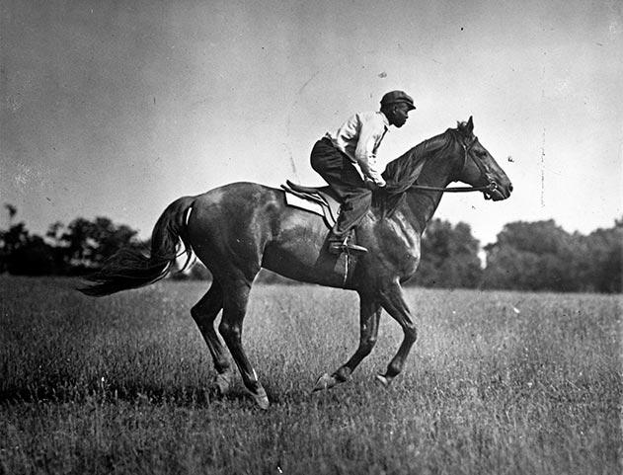
“De Mostest Hoss”

“The sports writers dubbed him „Big Red,‟ but his groom, Will Harbut, called him ”de mostest hoss” and that was a better description of Man O‟War. He was an amazing combination of size (1,150 pounds) and speed (five American records in 1920 alone), with an appetite so great that he reportedly was fed
with a bit in his mouth to slow down his eating. Man O‟War won 20 of his 21 starts in 1919 and 1920; at least once he ran away from the field by 100 lengths, a figure in keeping with the odds in his favor, which was three times reached 1 to 100. In the one race he lost—to a horse named, naturally, Upset—he was
victimized by a poor start and was gaining rapidly at the finish. Early Sande, the premier jockey of the decade, rode Man O‟War only once and never forgot it. „That day, I knew I was riding the greatest horse ever bred for running,‟ he said. The New York Tribune ran the following account of Man O‟War‟s most exciting
victory in 1920.”

Al Capone
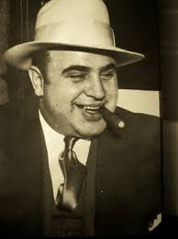
1899-1947

Born in 1899 in Brooklyn, New York, to poor immigrant parents, Al Capone went on to become the most infamous gangster in American history. In 1920 during the height of Prohibition, Capone's multi-million dollar Chicago operation in bootlegging, prostitution and gambling dominated the organized crime scene. Capone was responsible for many brutal acts of violence, mainly against other gangsters. The most famous of these was the St. Valentine's Day Massacre in 1929, in which he ordered the assassination of seven rivals. Capone was never indicted for his racketeering but was finally brought to justice for income-tax evasion in 1931. After serving six-and-a-half years, Capone was released. He died in 1947 in Miami. Capone's life captured the public imagination, and his gangster persona has been immortalized in the many movies and books inspired by his exploits.
The Roaring Twenties: Station Five
Flappers
Women of the 1920s

“The „20s were an exciting—and perhaps a frightening—time to be young. It was an era of the First Youth Rebellion. Once boys had tried to be perfect models of gallantry, industry and idealism; girls had aspired
to seem modest and maidenly. Now all that had changed. „The uncertainties of 1919 were over,‟ F. Scott Fitzgerald wrote. „America was going on the greatest, gaudiest spree in history.‟ The new questioning of their elders‟ authority, combined with the relative affluence of the decade, spawned a breed of youngsters who
claimed to be hardboiled, heavy-drinking and daring—and sometimes were. The girls in particular seemed to have changed. Skirts were shorter than ever before. Cloche hats, silk stockings, fake jewelry, bobbed hair replaced the osprey plumes, hobble skirts and flowing tresses of yesteryear. The advent of Prohibition made secret drinking an appealing game; women took up smoking; sales of cigarettes doubled during the decade.

Morals were undergoing a revolution. More and more college-age boys owned automobiles—and were parking them on dark roads to „neck‟ with their dates…Inevitably, the daring clothes, the scandalous dances
and sensual jazz, the late-night parties and cynical opinions of the young drew the wrath of many members of the older generation. „The situation,‟ declared a Southern Baptist publication, „causes grave
concern on the part of all who have the ideals at heart of purity and home life and the stability of our American civilization.‟ But America's young people didn‟t care. They went right on in their heedless, happy way, adopting outrageous fashions and singing, „In the meantime, in between time, ain’t we got fun?”

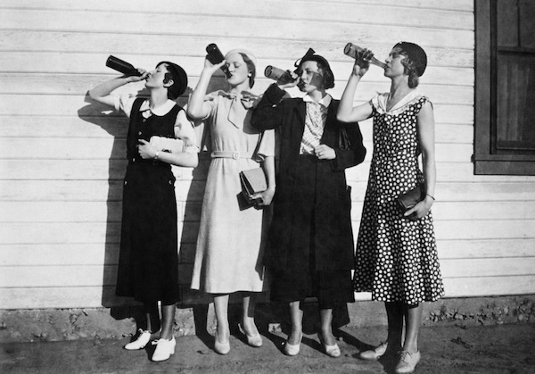 | 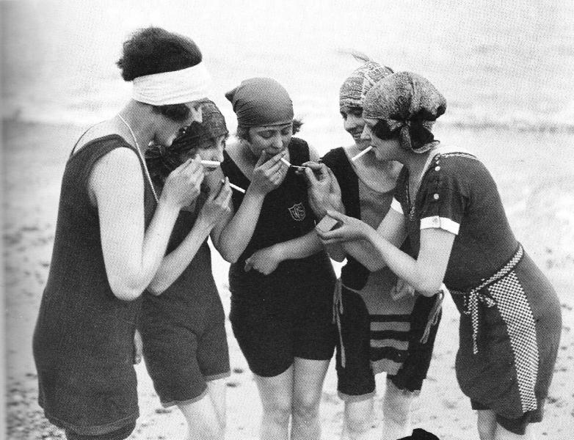

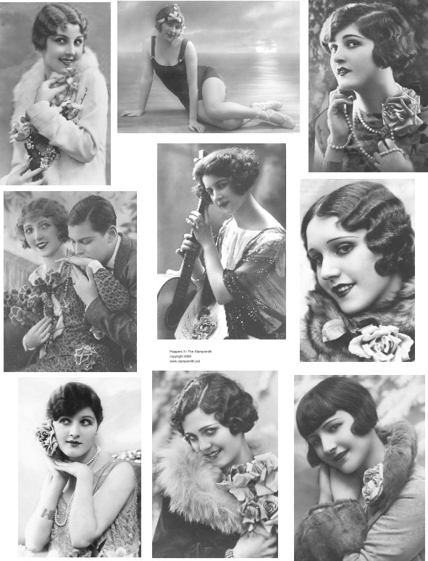

The Roaring Twenties: Station Six

1920s Slang

The exuberant, 20s were extraordinarily fertile years for language in America; dozens of new words and expressions sprang into existence. Much of the new verbiage was scornful of established ways; no less than half a dozen of the terms are roughly synonymous words meaning “nonsense.” A partial list of terms that were coined or popularized in the decade appears below.

All wet | wrong; arguing a mistaken notion or belief. | Cake-eater | a ladies‟ man.
Applesauce | a term of derogation; nonsense; same as baloney, bunk, banana oil, hokum, and horsefeathers | Carry a torch | to suffer from unrequited love
Baloney | nonsense | Cat’s meow | anything wonderful; similar to bee‟s knees,  berries.
Banana oil | nonsense | Cheaters | eyeglasses
Bee’s knees | a superb person or thing | Copacetic | excellent.
Berries | anything wonderful; similar to bee’s knees. | Crush | an infatuation with a person
Bible belt | an area in the South or south Midwest where  Fundamentalist religion prevails | Darb | an excellent person or thing.
Big cheese | an important person | Dogs | human feet.
Bull session | an informal group discussion | Drugstore  cowboy | a fashionably dressed idler who hangs around  public places trying to pick up girls.
Bump off | to murder | Dumb Dora | a stupid girl.

Fall guy | a scapegoat | Sheba | a beautiful young woman
Flapper | a typical young girl of the 20s, usually with  bobbed hair, short skirts and rolled stockings. | Sheik | a handsome young man
Flat tire | a dull, boring person. | Smeller | the nose.
Gam | a girl’s leg. | Speakeasy | a saloon or bar selling bootleg whiskey
Giggle water | an alcoholic drink. | Spiffy | having an elegantly fashionable appearance.
Gold digger | a woman who uses feminine charm to extract money from a man. | Struggle buggy | a car
Hard-boiled | tough; without sentiment. | Stuck on | having a crush on.
Heebie-jeebies | the jitters,scared. | Swanky | ritzy.
Hokum | nonsense. | Swell | marvelous.
Hooch | bootleg liquor | Torpedo | a hired gunman.
Hotsy-totsy | pleasing. | Upchuck | to vomit.
Jake | okay | Whoopee | boisterous fun.
Jalopy | an old car.
Kisser | the mouth
Main drag | the most important street in a town or city.
Neck | to caress intimately.
Pinch | to arrest.
Ritzy | elegant
Real McCoy | the  the genuine article
Run-around | deceptive or delaying action, especially in  response to a request.
Scram | to leave hurriedly

Enriched American History
1920s Round Robin
December 2014
30 Points

Name: ________________________

The Roaring Twenties: Station One

1) Why did prohibition go into effect in the first place? ______________________________________________________________________________________________________________________________________________________________________________________________________________________________

2) What is the temperance movement? ______________________________________________________________________________________________________________________________________________________________________________________________________________________________

3) What did the 18th Amendment and the Volstead Act do? ______________________________________________________________________________________________________________________________________________________________________________________________________________________________

4) How did people manage to get a hold of alcohol in the 1920s? ______________________________________________________________________________________________________________________________________________________________________________________________________________________________

5) What did the 21st amendment do?
____________________________________________________________________________________________________________________________________________________

6) Look at the two pictures that are in support of prohibition…What do these pictures tell you about the prohibition movement?
______________________________________________________________________________________________________________________________________________________________________________________________________________________________
__________________________________________________________________________

7) Identify three of the biggest “issues” surrounding the passage of the 18th amendment. (not in reading)
__________________________________________________________________________________________________________________________________________________________________________________________________________________________________________________________________________________________________________________________________________________________________________________

The Roaring Twenties: Station Two

1) What did the 19th amendment do? Why did it take so long in your opinion? ____________________________________________________________________________________________________________________________________________________

2) Looking at the political cartoons, what are some of the reasons why men oppose women’s
suffrage?
______________________________________________________________________________________________________________________________________________________________________________________________________________________________

Imagine you were a suffragette. Design a poster showing your support for the movement.

The Roaring Twenties: Station Three

1) What was the Harlem Renaissance?
______________________________________________________________________________________________________________________________________________________________________________________________________________________________

2) What did Locke mean when he said “Negro life is seizing its first chances for group expression and self determination.”
______________________________________________________________________________________________________________________________________________________________________________________________________________________________

3) What did much of the literature from the time period focus on?
______________________________________________________________________________________________________________________________________________________________________________________________________________________________

4) What movement provided more attention to the Harlem Renaissance?
______________________________________________________________________________________________________________________________________________________________________________________________________________________________

5) Look at the picture, what is it depicting?
______________________________________________________________________________________________________________________________________________________________________________________________________________________________

The Roaring Twenties: Station Four

1) In what year did Charles Lindbergh take off from Roosevelt Field, Long Island?
__________________________________________________________________________

2) How long was the flight (in hours)?
__________________________________________________________________________

3) What was remarkable about Lindbergh’s flight?
______________________________________________________________________________________________________________________________________________________________________________________________________________________________

4) How many home runs did Babe Ruth hit by 1927?
__________________________________________________________________________

5) What about Babe Ruth made him stand out?
______________________________________________________________________________________________________________________________________________________________________________________________________________________________

6) Define “uncouth” and “imbiber.”
______________________________________________________________________________________________________________________________________________________________________________________________________________________________

7) What was Man O’War’s nickname, and who gave it to him?
____________________________________________________________________________________________________________________________________________________

8) How many races did this horse win and how many did he lose?
____________________________________________________________________________________________________________________________________________________

9)How did Capone make his millions?
____________________________________________________________________________________________________________________________________________________

10) What is the most famous thing Capone is famous for?
____________________________________________________________________________________________________________________________________________________

11) What charges was Capone finally convicted of?
____________________________________________________________________________________________________________________________________________________

The Roaring Twenties: Station Five

1) How did boys behave prior to the Twenties?
______________________________________________________________________________________________________________________________________________________________________________________________________________________________

2) How did girls behave prior to the Twenties?
______________________________________________________________________________________________________________________________________________________________________________________________________________________________

3) How did F. Scott Fitzgerald describe this time period?
______________________________________________________________________________________________________________________________________________________________________________________________________________________________

4) Draw a flapper including hair and dress.

The Roaring Twenties: Station Six

Imagine you were a teenager living in the 1920s. Using at least ten slang words, write a short story describing your day.

______________________________________________________________________________________________________________________________________________________________________________________________________________________________
______________________________________________________________________________________________________________________________________________________________________________________________________________________________
______________________________________________________________________________________________________________________________________________________________________________________________________________________________
______________________________________________________________________________________________________________________________________________________________________________________________________________________________
______________________________________________________________________________________________________________________________________________________________________________________________________________________________
______________________________________________________________________________________________________________________________________________________________________________________________________________________________
______________________________________________________________________________________________________________________________________________________________________________________________________________________________
______________________________________________________________________________________________________________________________________________________________________________________________________________________________
______________________________________________________________________________________________________________________________________________________________________________________________________________________________
______________________________________________________________________________________________________________________________________________________________________________________________________________________________
______________________________________________________________________________________________________________________________________________________________________________________________________________________________

