Name:________________________________ Period:________________

Fill out this map including:
- Names of countries
- Names of Capitals
- Bodies of water
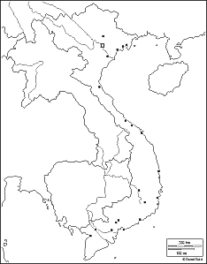

Answer questions on back of sheet.

- What large country took over Vietnam for over 750 years beginning around 200 AD?
- Why did they take them over?
- What country took Vietnam over during European Imperialism?
- Who is the man who wanted to make Vietnam an independent nation based on Communism?
- What were the results of the Geneva Conference of 1954?
- Who is Ngo Dinh Diem?
- What is the National Liberation Front?
- How many U.S. troops were in Vietnam by December 1960?
- Who was the American ambassador to Vietnam in 1963?
- Why is that we will never know how John F. Kennedy would have handled the Vietnam conflict?

