|  |  |
| --- | --- |
| Why did the US purchase Louisiana (LA) from France? |  |
| How did President Jefferson justify the purchase of Louisiana? |  |
| Who did President Jefferson select to lead the exploration of Louisiana? (2 men) |  |
| What rivers did Lewis and Clark follow while exploring LA? (2 rivers) |  |
| What animals did Lewis and Clark record seeing in their journals? (at least 4) |  |

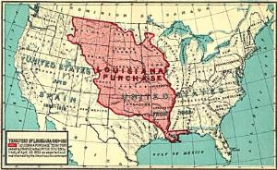

|  |  |
| --- | --- |
| Describe dangers that Lewis and Clark encountered while exploring LA (at least 5) |  |
| What Native American tribes did Lewis and Clark meet during their exploration? (at least 2) |  |
| What did Lewis and Clark accomplish in their exploration? (3 things) |  |

**Summary-** Write a 7 – 10 sentence summary of the Lewis and Clark Expedition (Corps of Discovery)